Replication
mongosh: 127.0.0.1:27017
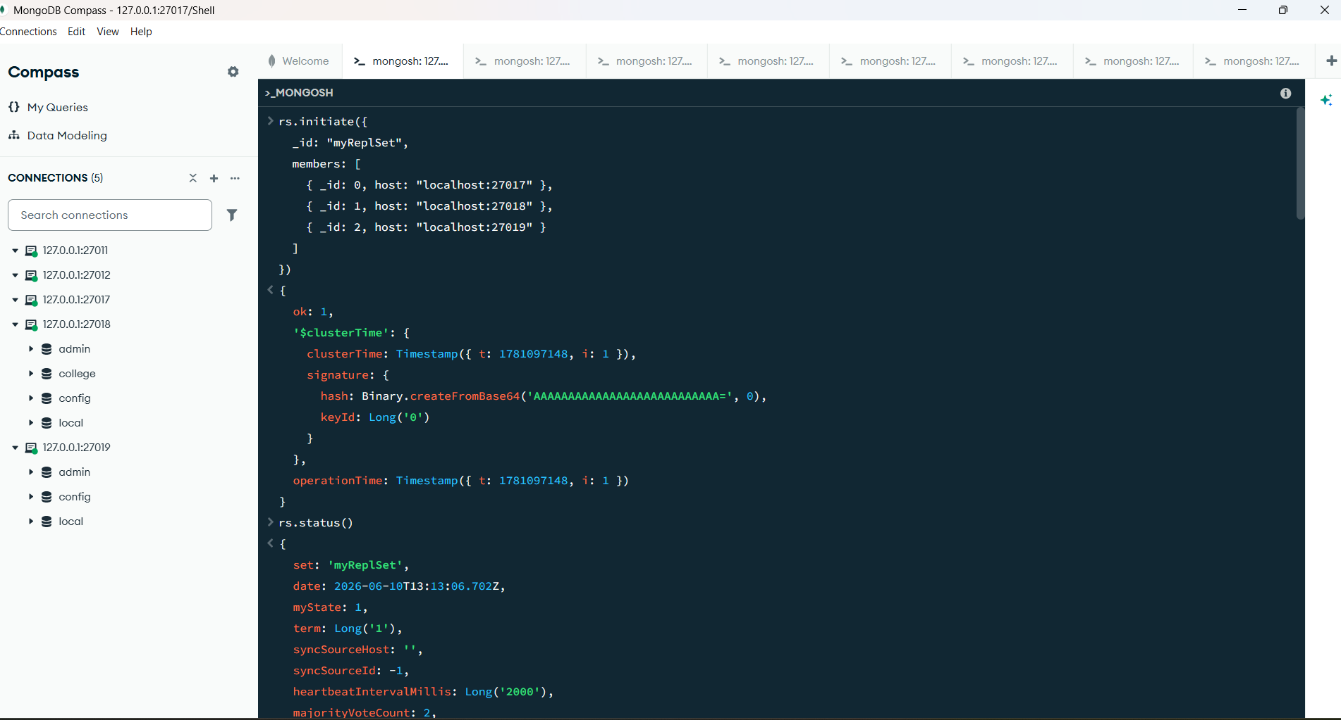

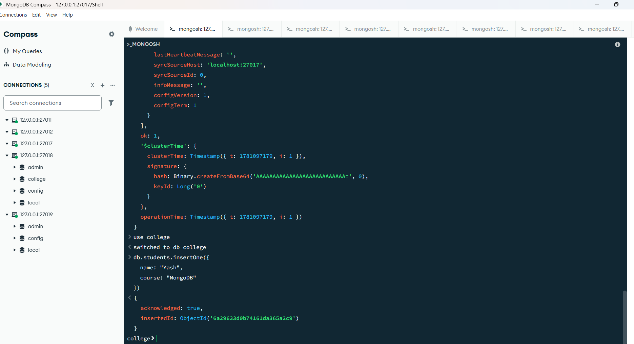
rs.initiate({
_id: "myReplSet",
members: [
{ _id: 0, host: "localhost:27017" },
{ _id: 1, host: "localhost:27018" },
{ _id: 2, host: "localhost:27019" }
]
})
{
ok: 1,
'$clusterTime': {
clusterTime: Timestamp({ t: 1781097148, i: 1 }),
signature: {
hash: Binary.createFromBase64('AAAAAAAAAAAAAAAAAAAAAAAAAAA=', 0),
keyId: Long('0')
}
},
operationTime: Timestamp({ t: 1781097148, i: 1 })
}
rs.status()
myState: 1,
_id: 1,
name: 'localhost:27018',
health: 1,
state: 2,
stateStr: 'SECONDARY',
uptime: 38,
optime: { ts: Timestamp({ t: 1781097179, i: 1 }), t: Long('1') },
optimeDurable: { ts: Timestamp({ t: 1781097179, i: 1 }), t: Long('1') },
optimeWritten: { ts: Timestamp({ t: 1781097179, i: 1 }), t: Long('1') },
optimeDate: 2026-06-10T13:12:59.000Z,
optimeDurableDate: 2026-06-10T13:12:59.000Z,
optimeWrittenDate: 2026-06-10T13:12:59.000Z,
lastAppliedWallTime: 2026-06-10T13:12:59.197Z,
lastDurableWallTime: 2026-06-10T13:12:59.197Z,
lastWrittenWallTime: 2026-06-10T13:12:59.197Z,
lastHeartbeat: 2026-06-10T13:13:05.242Z,
lastHeartbeatRecv: 2026-06-10T13:13:06.256Z,
pingMs: Long('0'),
lastHeartbeatMessage: '',
syncSourceHost: 'localhost:27017',
syncSourceId: 0,
infoMessage: '',
configVersion: 1,
configTerm: 1
},
{
_id: 2,
name: 'localhost:27019',
health: 1,
state: 2,
stateStr: 'SECONDARY',
uptime: 38,
optime: { ts: Timestamp({ t: 1781097179, i: 1 }), t: Long('1') },
optimeDurable: { ts: Timestamp({ t: 1781097179, i: 1 }), t: Long('1') },
optimeWritten: { ts: Timestamp({ t: 1781097179, i: 1 }), t: Long('1') },
optimeDate: 2026-06-10T13:12:59.000Z,
optimeDurableDate: 2026-06-10T13:12:59.000Z,
optimeWrittenDate: 2026-06-10T13:12:59.000Z,
lastAppliedWallTime: 2026-06-10T13:12:59.197Z,
lastDurableWallTime: 2026-06-10T13:12:59.197Z,
lastWrittenWallTime: 2026-06-10T13:12:59.197Z,
lastHeartbeat: 2026-06-10T13:13:05.242Z,
lastHeartbeatRecv: 2026-06-10T13:13:06.255Z,
pingMs: Long('0'),
lastHeartbeatMessage: '',
syncSourceHost: 'localhost:27017',
syncSourceId: 0,
infoMessage: '',
configVersion: 1,
configTerm: 1
}
],
ok: 1,
'$clusterTime': {
clusterTime: Timestamp({ t: 1781097179, i: 1 }),
signature: {
hash: Binary.createFromBase64('AAAAAAAAAAAAAAAAAAAAAAAAAAA=', 0),
keyId: Long('0')
}
},
operationTime: Timestamp({ t: 1781097179, i: 1 })
}
use college
switched to db college
db.students.insertOne({
name: "Yash",
course: "MongoDB"
})
{
acknowledged: true,
insertedId: ObjectId('6a29633d0b74161da365a2c9')
}
college

mongosh: 127.0.0.1:27018

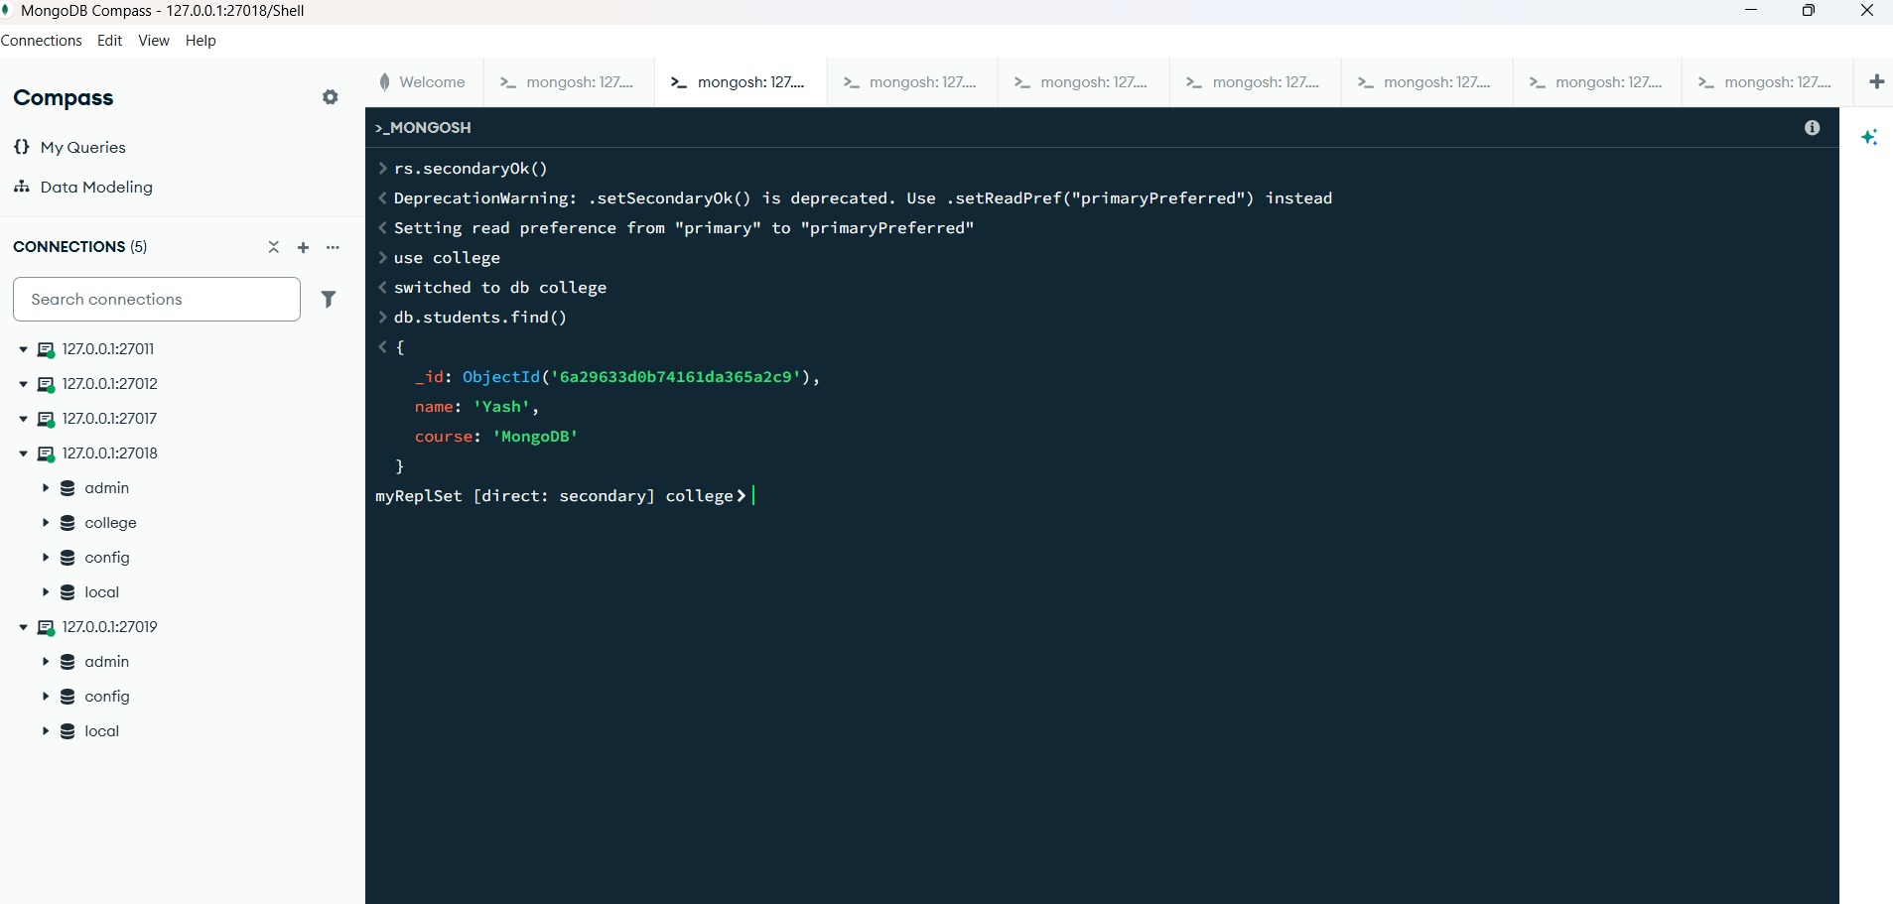

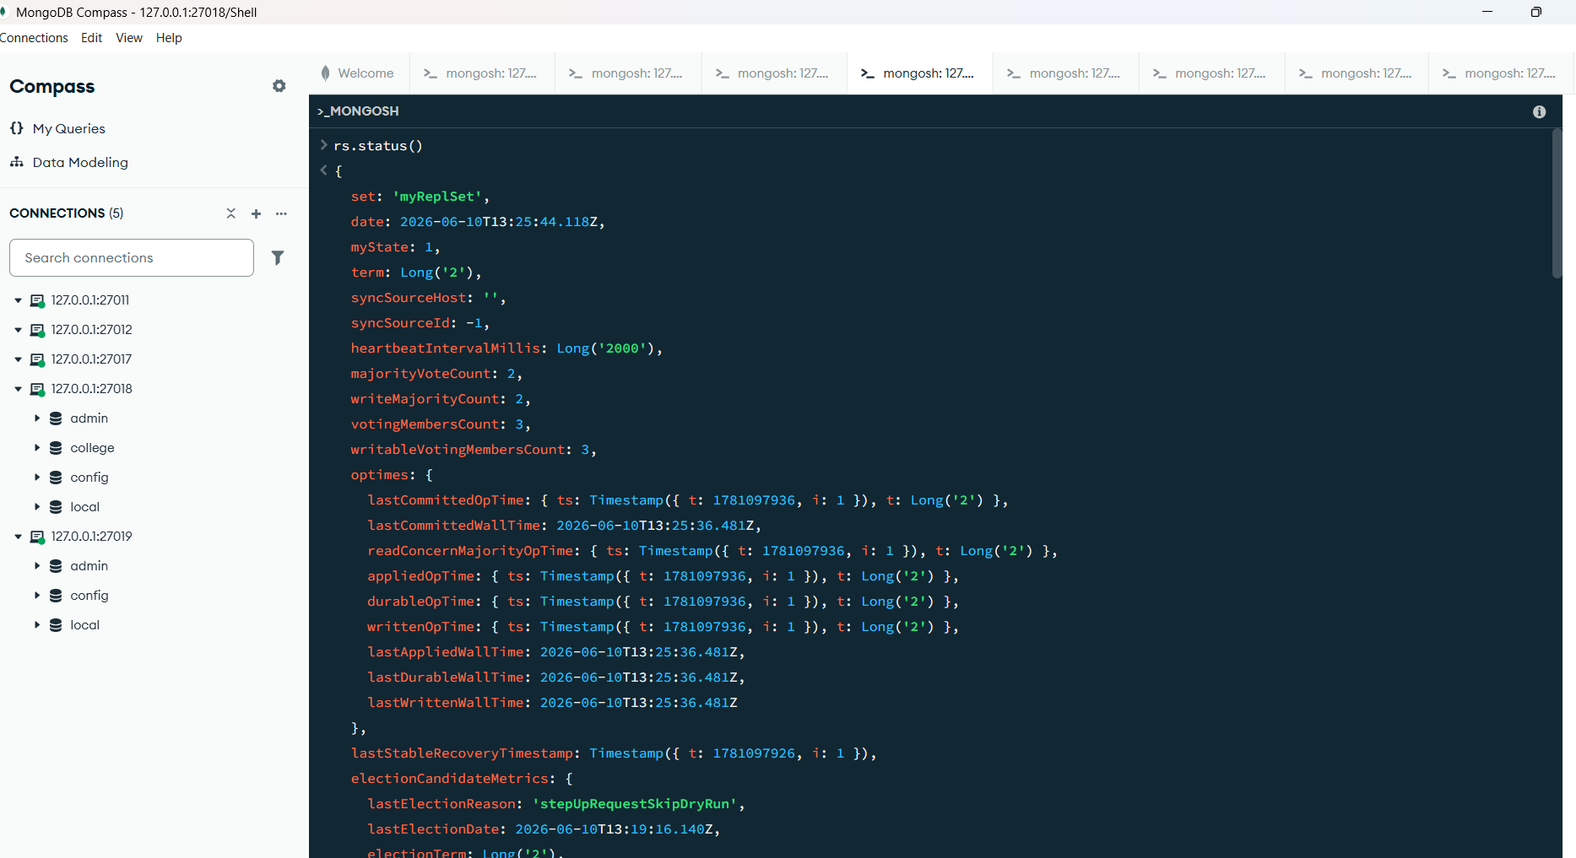

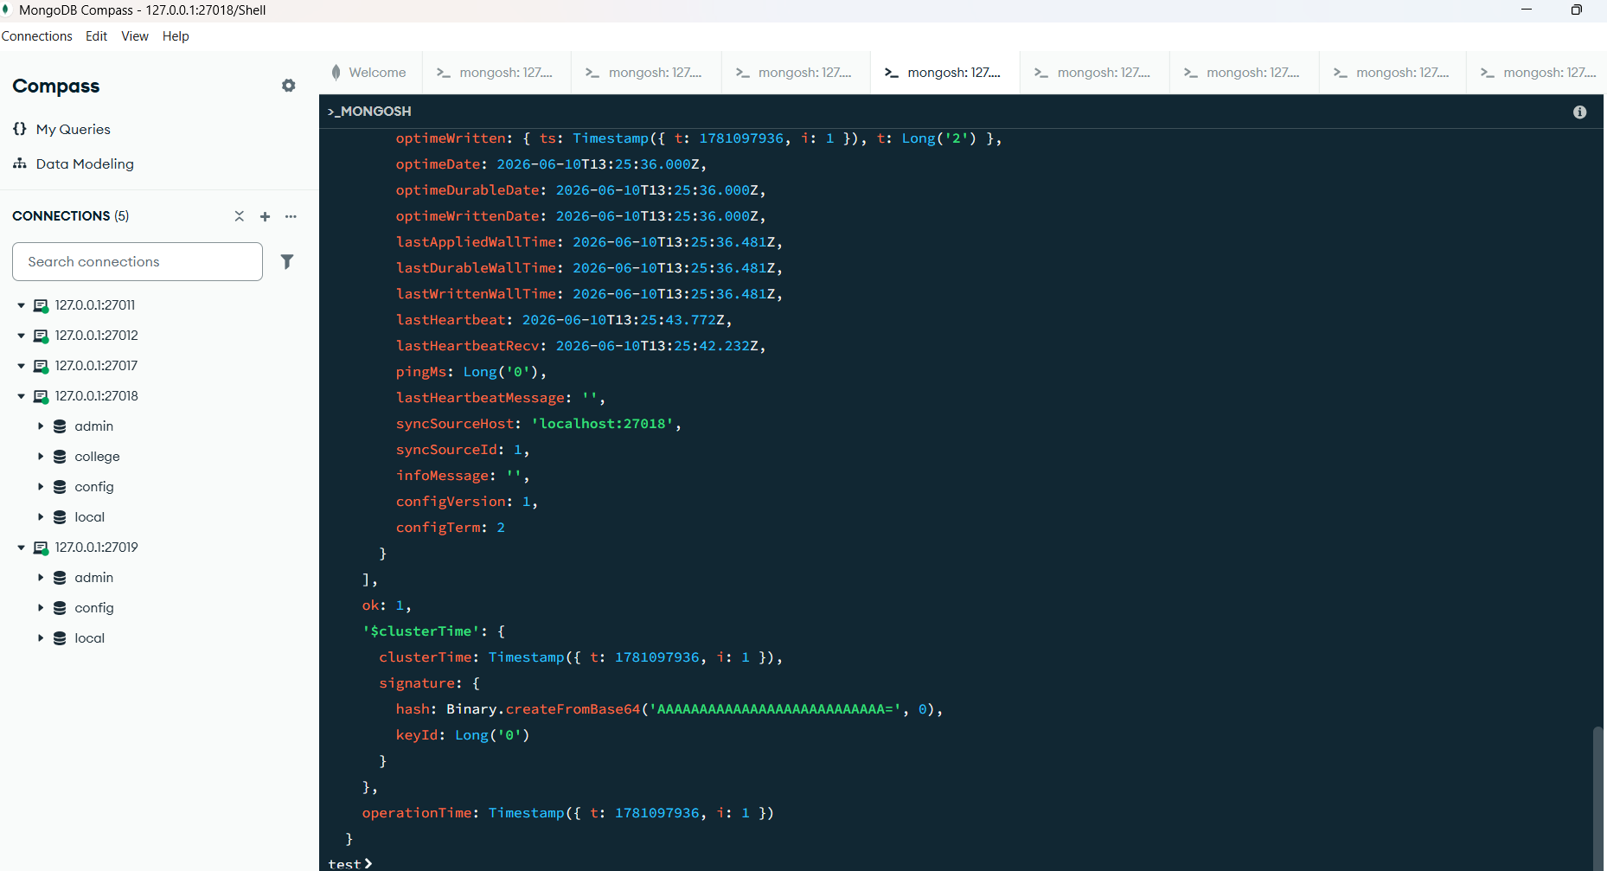

rs.status()
optime: { ts: Timestamp({ t: 1781097936, i: 1 }), t: Long('2') },
optimeDate: 2026-06-10T13:25:36.000Z,
optimeWritten: { ts: Timestamp({ t: 1781097936, i: 1 }), t: Long('2') },
optimeWrittenDate: 2026-06-10T13:25:36.000Z,
lastAppliedWallTime: 2026-06-10T13:25:36.481Z,
lastDurableWallTime: 2026-06-10T13:25:36.481Z,
lastWrittenWallTime: 2026-06-10T13:25:36.481Z,
syncSourceHost: '',
syncSourceId: -1,
infoMessage: '',
electionTime: Timestamp({ t: 1781097556, i: 1 }),
electionDate: 2026-06-10T13:19:16.000Z,
configVersion: 1,
configTerm: 2,
self: true,
lastHeartbeatMessage: ''
},
{
_id: 2,
name: 'localhost:27019',
health: 1,
state: 2,
stateStr: 'SECONDARY',
uptime: 795,
optime: { ts: Timestamp({ t: 1781097936, i: 1 }), t: Long('2') },
optimeDurable: { ts: Timestamp({ t: 1781097936, i: 1 }), t: Long('2') },
optimeWritten: { ts: Timestamp({ t: 1781097936, i: 1 }), t: Long('2') },
optimeDate: 2026-06-10T13:25:36.000Z,
optimeDurableDate: 2026-06-10T13:25:36.000Z,
optimeWrittenDate: 2026-06-10T13:25:36.000Z,
lastAppliedWallTime: 2026-06-10T13:25:36.481Z,
lastDurableWallTime: 2026-06-10T13:25:36.481Z,
lastWrittenWallTime: 2026-06-10T13:25:36.481Z,
lastHeartbeat: 2026-06-10T13:25:43.772Z,
lastHeartbeatRecv: 2026-06-10T13:25:42.232Z,
pingMs: Long('0'),
lastHeartbeatMessage: '',
syncSourceHost: 'localhost:27018',
syncSourceId: 1,
infoMessage: '',
configVersion: 1,
configTerm: 2
}
],
ok: 1,
'$clusterTime': {
clusterTime: Timestamp({ t: 1781097936, i: 1 }),
signature: {
hash: Binary.createFromBase64('AAAAAAAAAAAAAAAAAAAAAAAAAAA=', 0),
keyId: Long('0')
}
},
operationTime: Timestamp({ t: 1781097936, i: 1 })
}
test

mongosh: 127.0.0.1:27017

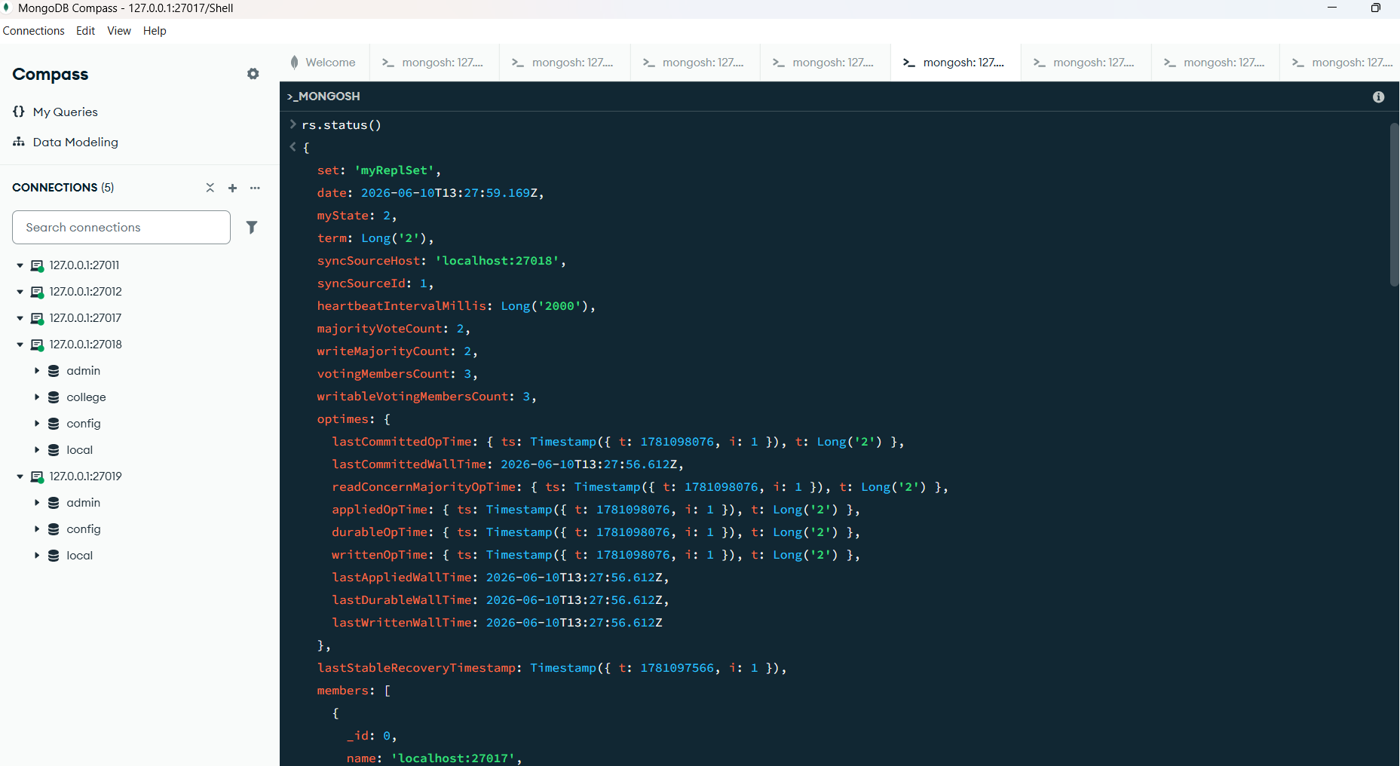

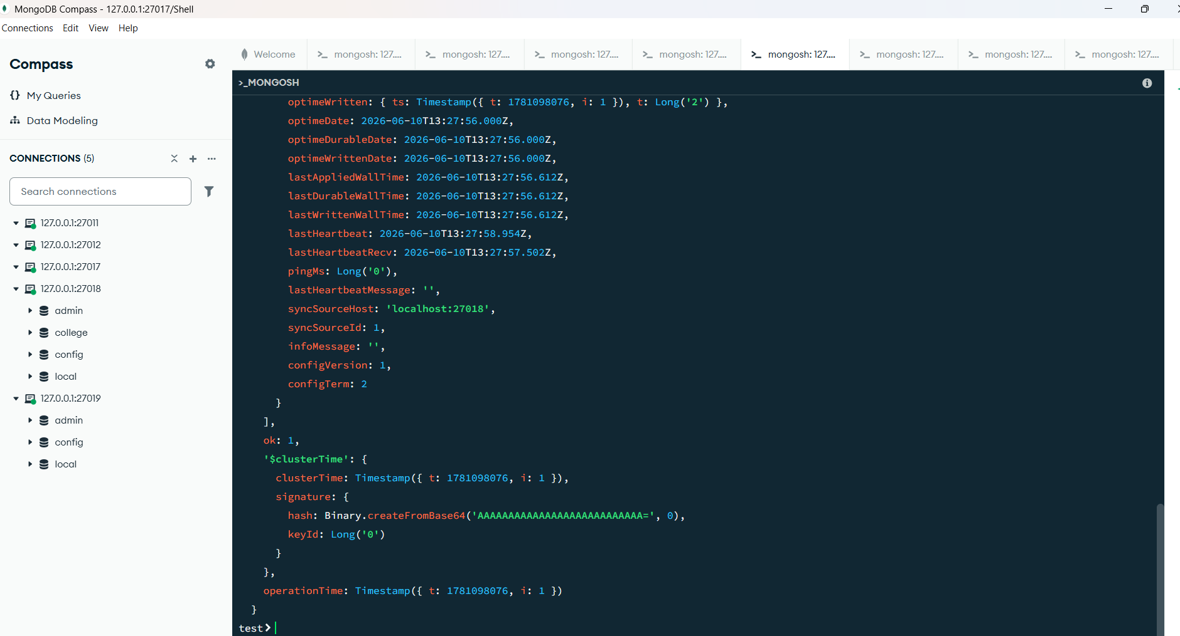

rs.status()
self: true,
lastHeartbeatMessage: ''
},
{
_id: 1,
name: 'localhost:27018',
health: 1,
state: 1,
stateStr: 'PRIMARY',
uptime: 41,
optime: { ts: Timestamp({ t: 1781098076, i: 1 }), t: Long('2') },
optimeDurable: { ts: Timestamp({ t: 1781098076, i: 1 }), t: Long('2') },
optimeWritten: { ts: Timestamp({ t: 1781098076, i: 1 }), t: Long('2') },
optimeDate: 2026-06-10T13:27:56.000Z,
optimeDurableDate: 2026-06-10T13:27:56.000Z,
optimeWrittenDate: 2026-06-10T13:27:56.000Z,
lastAppliedWallTime: 2026-06-10T13:27:56.612Z,
lastDurableWallTime: 2026-06-10T13:27:56.612Z,
lastWrittenWallTime: 2026-06-10T13:27:56.612Z,
lastHeartbeat: 2026-06-10T13:27:58.954Z,
lastHeartbeatRecv: 2026-06-10T13:27:57.738Z,
pingMs: Long('0'),
lastHeartbeatMessage: '',
syncSourceHost: '',
syncSourceId: -1,
infoMessage: '',
electionTime: Timestamp({ t: 1781097556, i: 1 }),
electionDate: 2026-06-10T13:19:16.000Z,
configVersion: 1,
configTerm: 2
},
{
_id: 2,
name: 'localhost:27019',
health: 1,
state: 2,
stateStr: 'SECONDARY',
uptime: 41,
optime: { ts: Timestamp({ t: 1781098076, i: 1 }), t: Long('2') },
optimeDurable: { ts: Timestamp({ t: 1781098076, i: 1 }), t: Long('2') },
optimeWritten: { ts: Timestamp({ t: 1781098076, i: 1 }), t: Long('2') },
optimeDate: 2026-06-10T13:27:56.000Z,
optimeDurableDate: 2026-06-10T13:27:56.000Z,
optimeWrittenDate: 2026-06-10T13:27:56.000Z,
lastAppliedWallTime: 2026-06-10T13:27:56.612Z,
lastDurableWallTime: 2026-06-10T13:27:56.612Z,
lastWrittenWallTime: 2026-06-10T13:27:56.612Z,
lastHeartbeat: 2026-06-10T13:27:58.954Z,
lastHeartbeatRecv: 2026-06-10T13:27:57.502Z,
pingMs: Long('0'),
lastHeartbeatMessage: '',
syncSourceHost: 'localhost:27018',
syncSourceId: 1,
infoMessage: '',
configVersion: 1,
configTerm: 2
}
],
ok: 1,
'$clusterTime': {
clusterTime: Timestamp({ t: 1781098076, i: 1 }),
signature: {
hash: Binary.createFromBase64('AAAAAAAAAAAAAAAAAAAAAAAAAAA=', 0),
keyId: Long('0')
}
},
operationTime: Timestamp({ t: 1781098076, i: 1 })
}
test

Sharding
mongosh: 127.0.0.1:27019
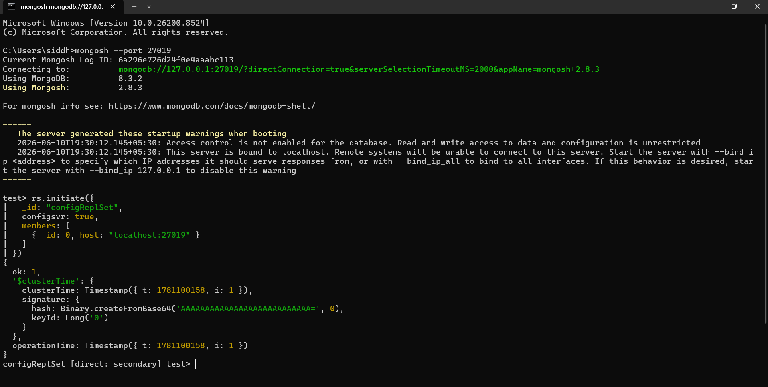
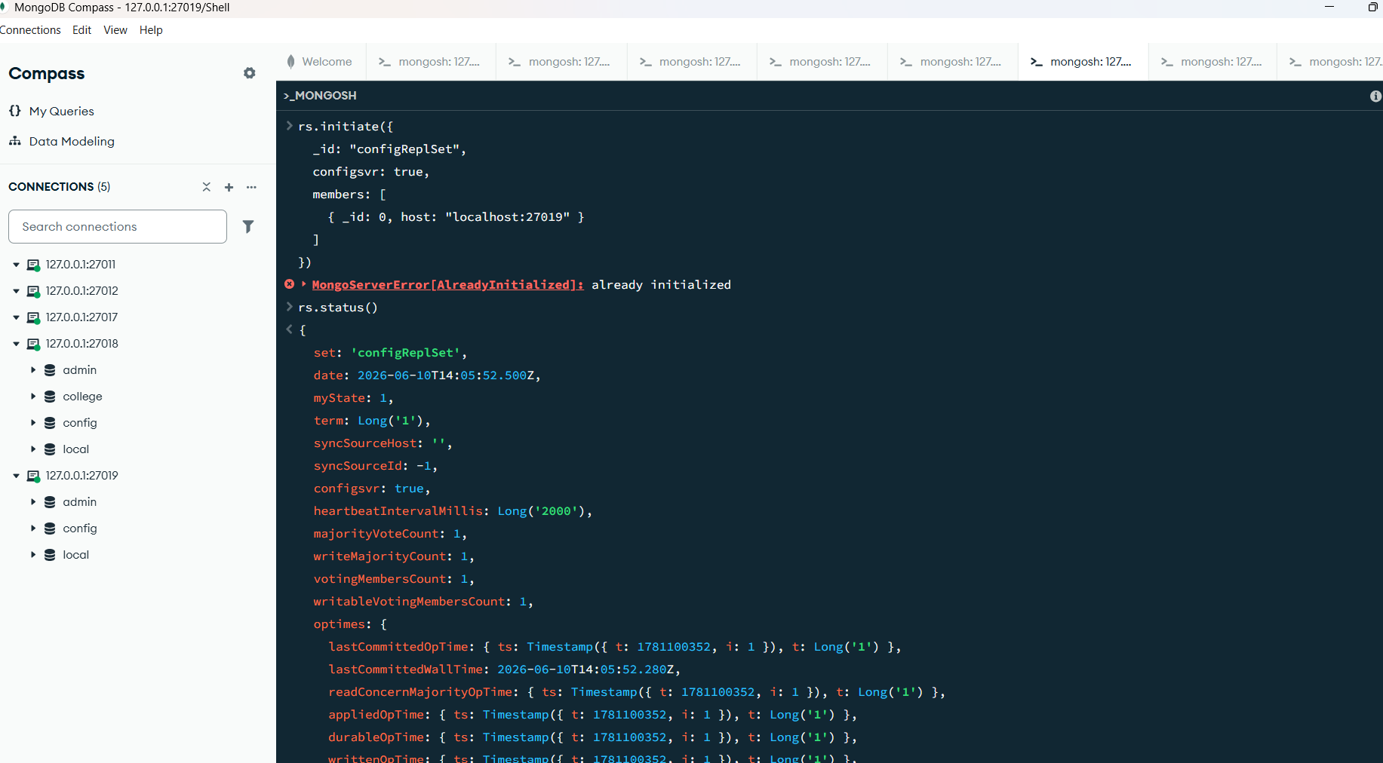

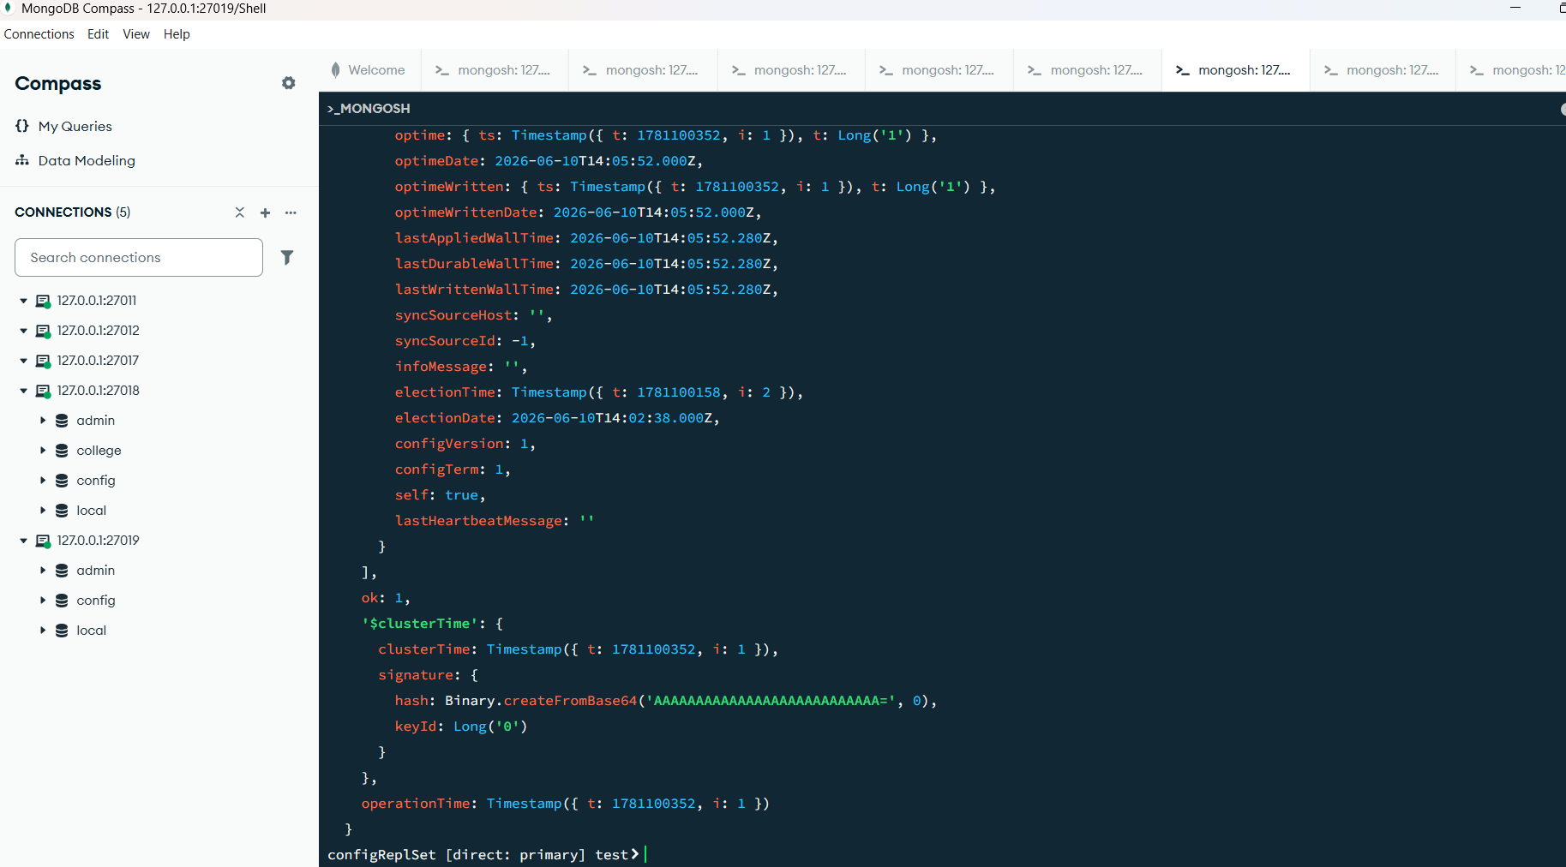
rs.initiate({
_id: "configReplSet",
configsvr: true,
members: [
{ _id: 0, host: "localhost:27019" }
]
})
MongoServerError[AlreadyInitialized]: already initialized
rs.status()
lastWrittenWallTime: 2026-06-10T14:05:52.280Z
},
lastStableRecoveryTimestamp: Timestamp({ t: 1781100338, i: 1 }),
electionCandidateMetrics: {
lastElectionReason: 'electionTimeout',
lastElectionDate: 2026-06-10T14:02:38.331Z,
electionTerm: Long('1'),
lastCommittedOpTimeAtElection: { ts: Timestamp({ t: 1781100158, i: 1 }), t: Long('-1') },
lastSeenWrittenOpTimeAtElection: { ts: Timestamp({ t: 1781100158, i: 1 }), t: Long('-1') },
lastSeenOpTimeAtElection: { ts: Timestamp({ t: 1781100158, i: 1 }), t: Long('-1') },
numVotesNeeded: 1,
priorityAtElection: 1,
electionTimeoutMillis: Long('10000'),
newTermStartDate: 2026-06-10T14:02:38.386Z,
wMajorityWriteAvailabilityDate: 2026-06-10T14:02:38.665Z
},
members: [
{
_id: 0,
name: 'localhost:27019',
health: 1,
state: 1,
stateStr: 'PRIMARY',
uptime: 341,
optime: { ts: Timestamp({ t: 1781100352, i: 1 }), t: Long('1') },
optimeDate: 2026-06-10T14:05:52.000Z,
optimeWritten: { ts: Timestamp({ t: 1781100352, i: 1 }), t: Long('1') },
optimeWrittenDate: 2026-06-10T14:05:52.000Z,
lastAppliedWallTime: 2026-06-10T14:05:52.280Z,
lastDurableWallTime: 2026-06-10T14:05:52.280Z,
lastWrittenWallTime: 2026-06-10T14:05:52.280Z,
syncSourceHost: '',
syncSourceId: -1,
infoMessage: '',
electionTime: Timestamp({ t: 1781100158, i: 2 }),
electionDate: 2026-06-10T14:02:38.000Z,
configVersion: 1,
configTerm: 1,
self: true,
lastHeartbeatMessage: ''
}
],
ok: 1,
'$clusterTime': {
clusterTime: Timestamp({ t: 1781100352, i: 1 }),
signature: {
hash: Binary.createFromBase64('AAAAAAAAAAAAAAAAAAAAAAAAAAA=', 0),
keyId: Long('0')
}
},
operationTime: Timestamp({ t: 1781100352, i: 1 })
}
configReplSet [direct: primary] test

mongosh: 127.0.0.1:27011

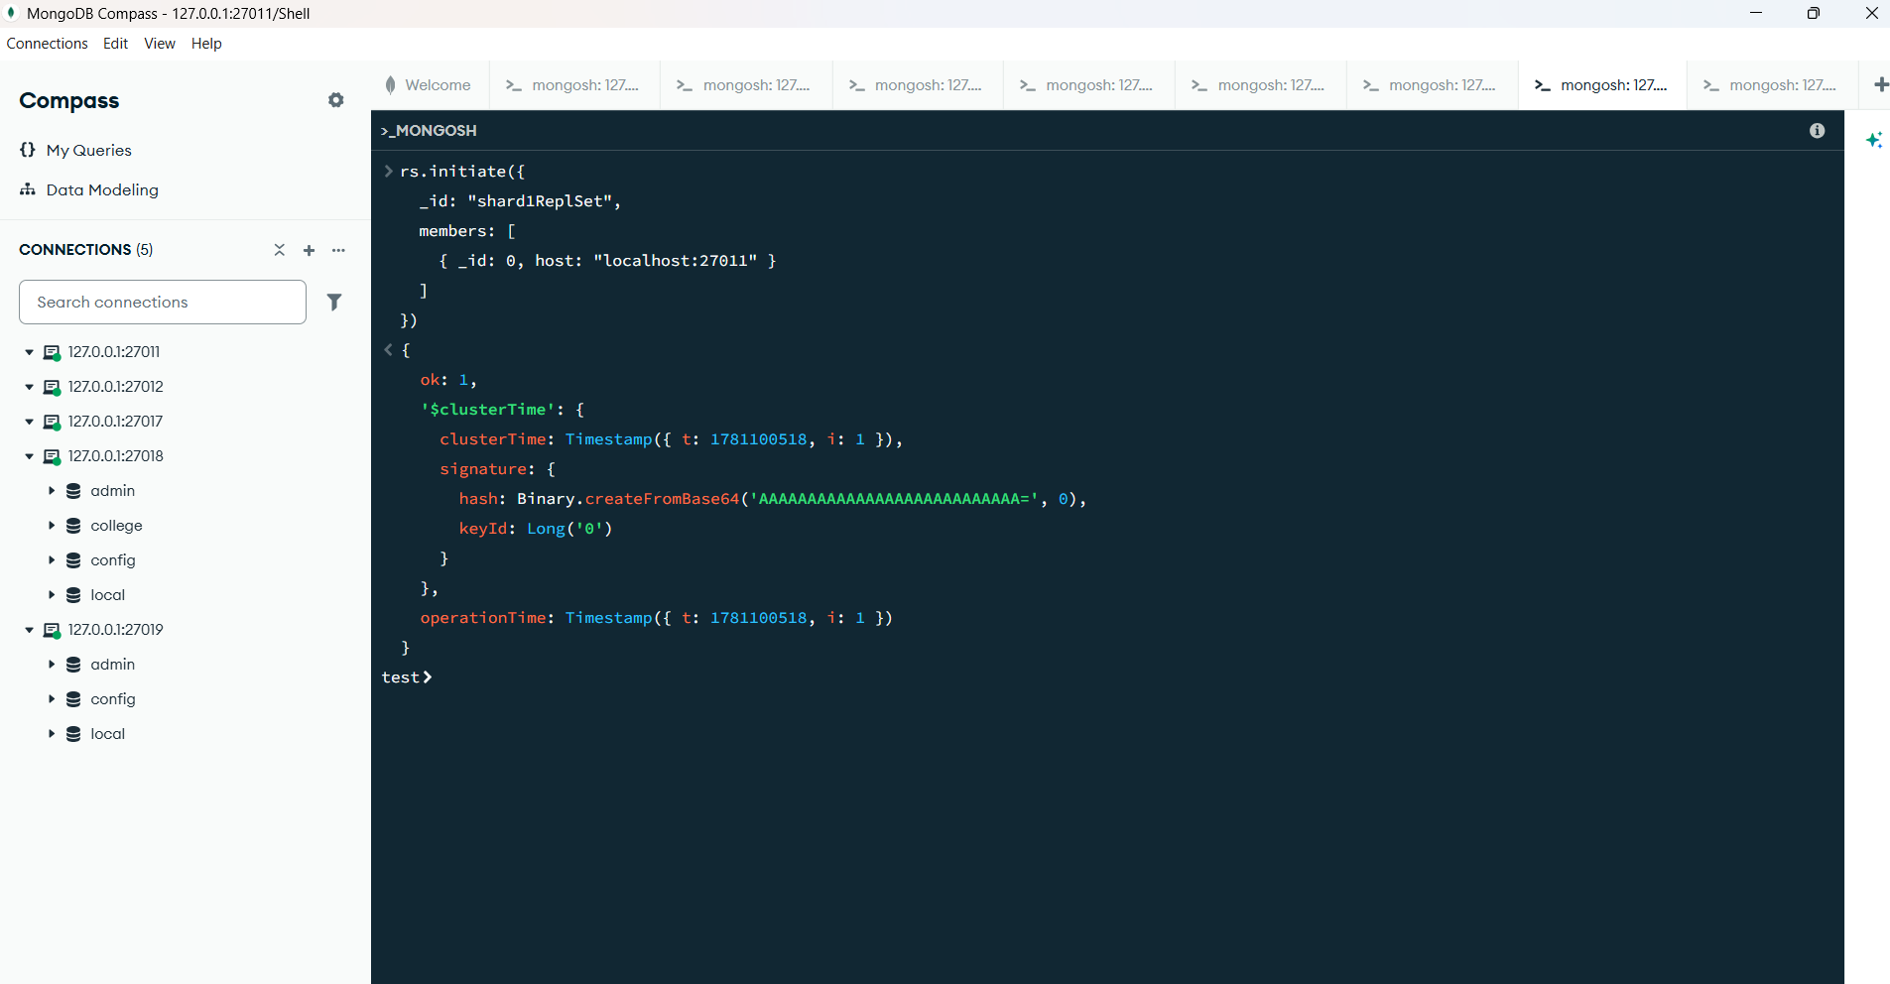

mongosh: 127.0.0.1:27012
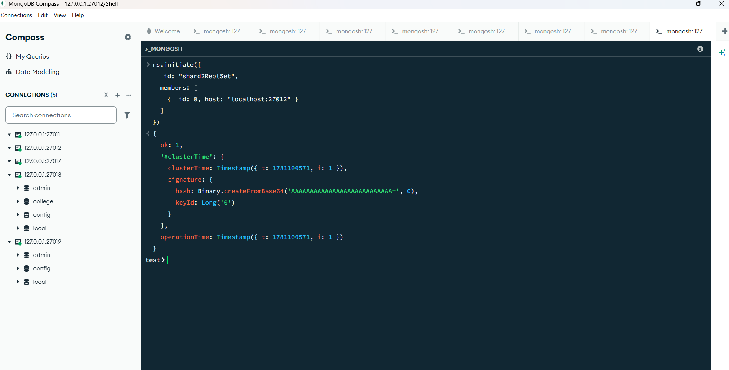

Microsoft Windows [Version 10.0.26200.8524]
(c) Microsoft Corporation. All rights reserved.

C:\Users\siddh>mongosh --port 27019
Current Mongosh Log ID: 6a2977b403c411a84fabc113
Connecting to: mongodb://127.0.0.1:27019/?directConnection=true&serverSelectionTimeoutMS=2000&appName=mongosh+2.8.3
Using MongoDB: 8.3.2
Using Mongosh: 2.8.3

For mongosh info see: https://www.mongodb.com/docs/mongodb-shell/

------
The server generated these startup warnings when booting
2026-06-10T19:30:12.145+05:30: Access control is not enabled for the database. Read and write access to data and configuration is unrestricted
2026-06-10T19:30:12.145+05:30: This server is bound to localhost. Remote systems will be unable to connect to this server. Start the server with --bind_ip <address> to specify which IP addresses it should serve responses from, or with --bind_ip_all to bind to all interfaces. If this behavior is desired, start the server with --bind_ip 127.0.0.1 to disable this warning
------

configReplSet [direct: primary] test> rs.status()
{
set: 'configReplSet',
date: ISODate('2026-06-10T14:42:07.139Z'),
myState: 1,
term: Long('1'),
syncSourceHost: '',
syncSourceId: -1,
configsvr: true,
heartbeatIntervalMillis: Long('2000'),
majorityVoteCount: 1,
writeMajorityCount: 1,
votingMembersCount: 1,
writableVotingMembersCount: 1,
optimes: {
lastCommittedOpTime: { ts: Timestamp({ t: 1781102526, i: 1 }), t: Long('1') },
lastCommittedWallTime: ISODate('2026-06-10T14:42:06.458Z'),
readConcernMajorityOpTime: { ts: Timestamp({ t: 1781102526, i: 1 }), t: Long('1') },
appliedOpTime: { ts: Timestamp({ t: 1781102526, i: 1 }), t: Long('1') },
durableOpTime: { ts: Timestamp({ t: 1781102526, i: 1 }), t: Long('1') },
writtenOpTime: { ts: Timestamp({ t: 1781102526, i: 1 }), t: Long('1') },
lastAppliedWallTime: ISODate('2026-06-10T14:42:06.458Z'),
lastDurableWallTime: ISODate('2026-06-10T14:42:06.458Z'),
lastWrittenWallTime: ISODate('2026-06-10T14:42:06.458Z')
},
lastStableRecoveryTimestamp: Timestamp({ t: 1781102500, i: 1 }),
electionCandidateMetrics: {
lastElectionReason: 'electionTimeout',
lastElectionDate: ISODate('2026-06-10T14:02:38.331Z'),
electionTerm: Long('1'),
lastCommittedOpTimeAtElection: { ts: Timestamp({ t: 1781100158, i: 1 }), t: Long('-1') },
lastSeenWrittenOpTimeAtElection: { ts: Timestamp({ t: 1781100158, i: 1 }), t: Long('-1') },
lastSeenOpTimeAtElection: { ts: Timestamp({ t: 1781100158, i: 1 }), t: Long('-1') },
numVotesNeeded: 1,
priorityAtElection: 1,
electionTimeoutMillis: Long('10000'),
newTermStartDate: ISODate('2026-06-10T14:02:38.386Z'),
wMajorityWriteAvailabilityDate: ISODate('2026-06-10T14:02:38.665Z')
},
members: [
{
_id: 0,
name: 'localhost:27019',
health: 1,
state: 1,
stateStr: 'PRIMARY',
uptime: 2516,
optime: { ts: Timestamp({ t: 1781102526, i: 1 }), t: Long('1') },
optimeDate: ISODate('2026-06-10T14:42:06.000Z'),
optimeWritten: { ts: Timestamp({ t: 1781102526, i: 1 }), t: Long('1') },
optimeWrittenDate: ISODate('2026-06-10T14:42:06.000Z'),
lastAppliedWallTime: ISODate('2026-06-10T14:42:06.458Z'),
lastDurableWallTime: ISODate('2026-06-10T14:42:06.458Z'),
lastWrittenWallTime: ISODate('2026-06-10T14:42:06.458Z'),
syncSourceHost: '',
syncSourceId: -1,
infoMessage: '',
electionTime: Timestamp({ t: 1781100158, i: 2 }),
electionDate: ISODate('2026-06-10T14:02:38.000Z'),
configVersion: 1,
configTerm: 1,
self: true,
lastHeartbeatMessage: ''
}
],
ok: 1,
'$clusterTime': {
clusterTime: Timestamp({ t: 1781102526, i: 1 }),
signature: {
hash: Binary.createFromBase64('AAAAAAAAAAAAAAAAAAAAAAAAAAA=', 0),
keyId: Long('0')
}
},
operationTime: Timestamp({ t: 1781102526, i: 1 })
}
configReplSet [direct: primary] test>

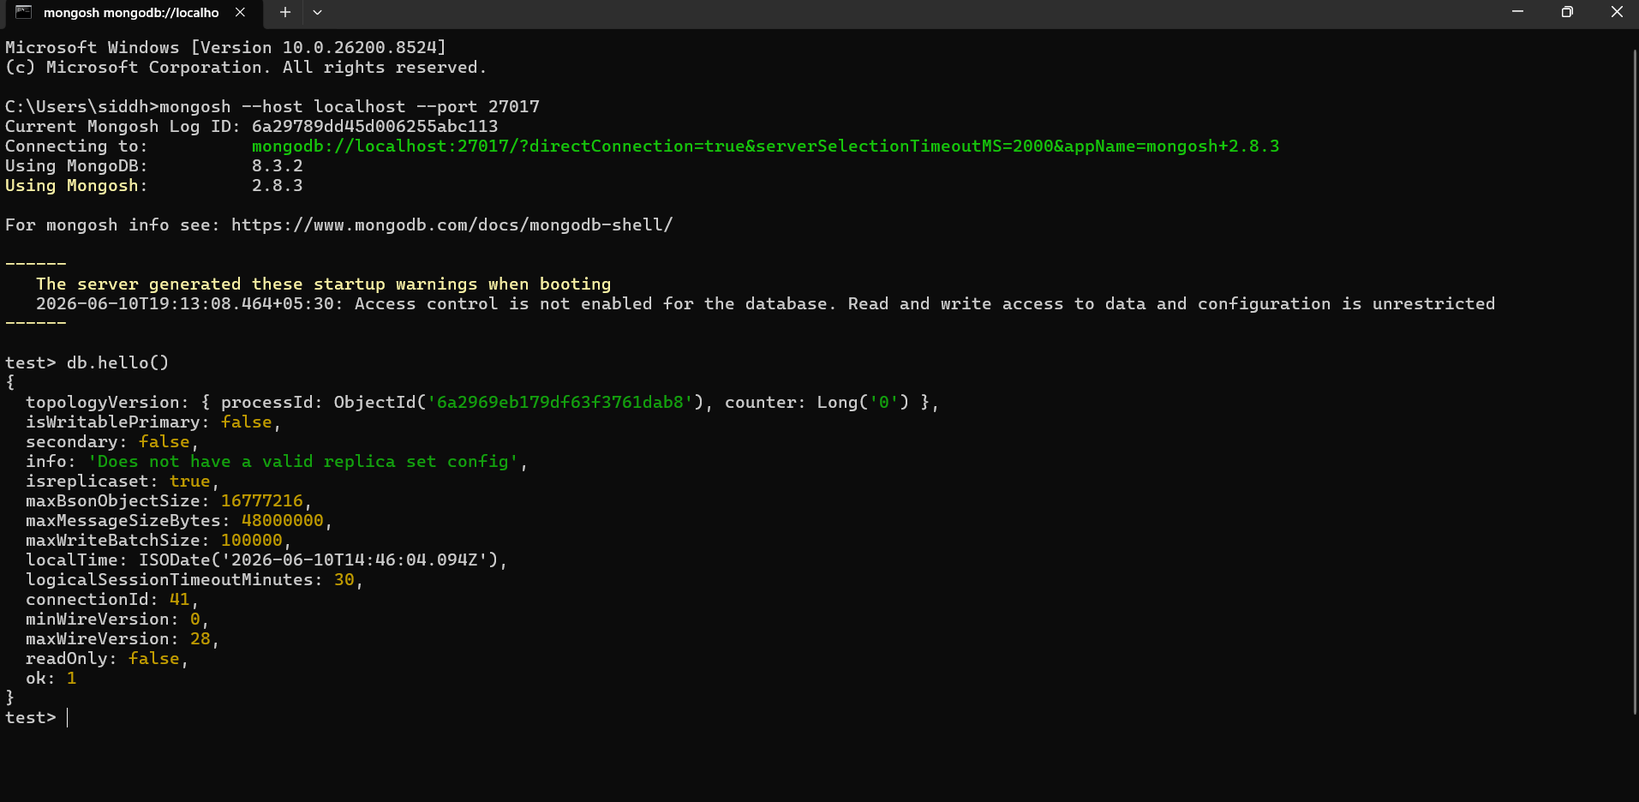

sh.addShard("shard1ReplSet/localhost:27011")
sh.addShard("shard2ReplSet/localhost:27012")
Warning: MongoshWarning: [SHAPI-10003] You are not connected to a mongos. This command may not work as expected. MongoServerError[CommandNotFound]: no such command: 'addShard'

